Terraform Deployment Script:

Deploying 2 Palo Alto Networks Firewalls + 1 Public Facing Load Balancer into Microsoft Azure

v1.0

1. Objective

This guide helps in the creation of the following infrastructure using Terraform.

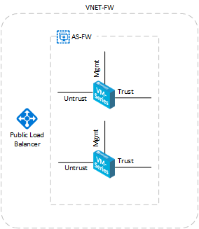

[*https://github.com/kblackstone/PaloAltoNetworks/tree/master/Terraform/2FW-1LB*](https://github.com/kblackstone/PaloAltoNetworks/tree/master/Terraform/2FW-1LB)

*The configuration of the firewall rules, load balancers, and other infrastructure is not included. Consult Azure documentation and your Palo Alto Networks sales team for assistance where needed.*

1. Download Terraform

Terraform can be downloaded from <http://terraform.io>. It is a single executable file that will be necessary to run the script provided. The version used during this example was for 32bit Windows. You will likely also want to download the Azure PowerShell Tools if you don’t already have them installed, and set the necessary path to run Terraform from any folder you wish. Directions for setting path are available at:

<https://www.terraform.io/intro/getting-started/install.html>

1. Account Variables

Terraform requires the necessary rights to access your account and create the design shown above. You can look these up in your account but to make this easier, a Microsoft developer provides a script that you run against your account to obtain:

* Client ID
* Client Secret
* Subscription ID
* Tenant ID

More information can be found here (read these before running the script):

<https://docs.microsoft.com/en-us/azure/virtual-machines/terraform-install-configure>

<https://blogs.msdn.microsoft.com/eugene/2016/11/03/creating-azure-resources-with-terraform/>

This script is located at: <https://github.com/echuvyrov/terraform101/blob/master/azureSetup.ps1>

With a backup copy at:

<https://github.com/kblackstone/PaloAltoNetworks/blob/master/Terraform/azureSetup.ps1>

1. Edit variables.tf

Once you have completed step 3, edit variables.tf and insert the necessary information as well as set the number of firewalls you want to build, the admin login name, and the admin password.

1. Edit main.tf

Main.tf contains the information that determines

* Resource Group Name
* Location
* VNET CIDR
* Subnets
* Storage Account
* Public IP Addresses for the Firewalls
* Network Interfaces
* Availability Set
* Public IP Address for the Public Facing Load Balancer
* Load Balancer Backend Pools
* Health Probe
* Load Balancer Rules
* Creates the Palo Alto Networks Firewalls

This script creates BYOL (bring your own license) versions of the Palo Alto Networks Firewalls. If you wish to use Bundle1 or Bundle2 which come with licensing, you can alter the code to make that indication.

1. Run Terraform

Once all necessary changes have been made, open PowerShell and run:

terraform plan

Once completed and ready for deployment run:

terraform apply

If you wish to delete the infrastructure run:

terraform destroy

1. Enjoy!

Please feel free to use, edit, or share this script as you please. It is not intended for production use and includes no support, so use wisely.